**Dynamic Deployment of Windows/Linux Web Servers Using AWS CloudFormation**

**Objective**

To build a single AWS CloudFormation Template (CFT) that:

* Accepts user input to choose Windows, Linux, or Both
* Provisions EC2 instances dynamically based on the input
* Installs IIS (Windows) or Apache (Linux) using User Data scripts
* Hosts a sample webpage from a public HTML template
* Supports deployment in both us-east-1 and us-east-2

**Requirements**

* OS Selection Parameter: Windows / Linux / Both
* Instance Type Parameter
* SSH Key Pair Name
* Default VPC Usage
* No custom AMIs (everything via user data)

**Architecture Flow Chart**

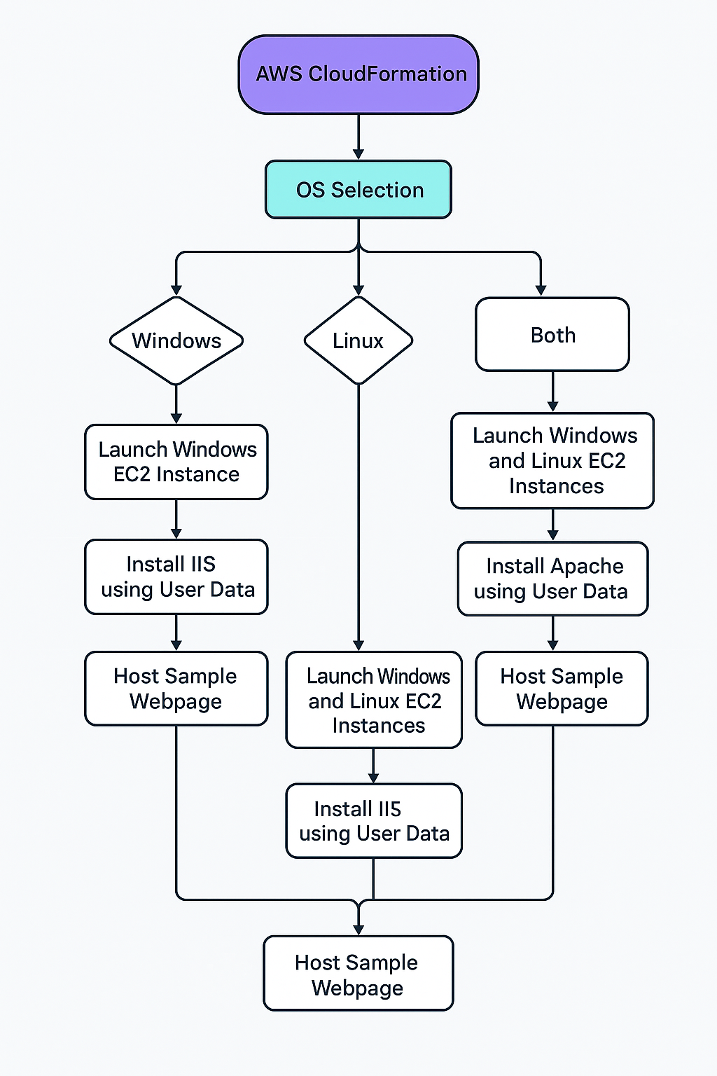

**Step-by-Step Execution**

**1. AWS Homepage**

* Go to the AWS homepage



**2. Login Page**

* Enter your credentials to log in

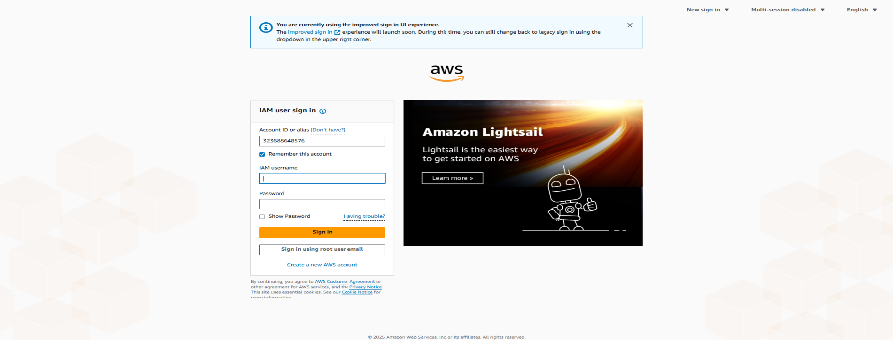

**3. AWS Console**

* Access the AWS Management Console

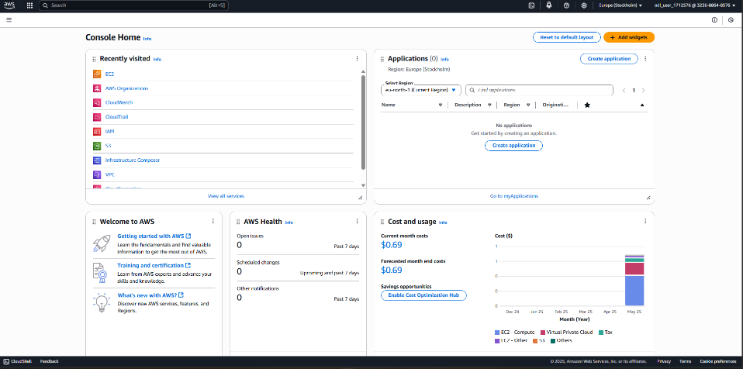

**4. CloudFormation Template**

* Upload the template file: Day3-Dynamic-webservers.yaml

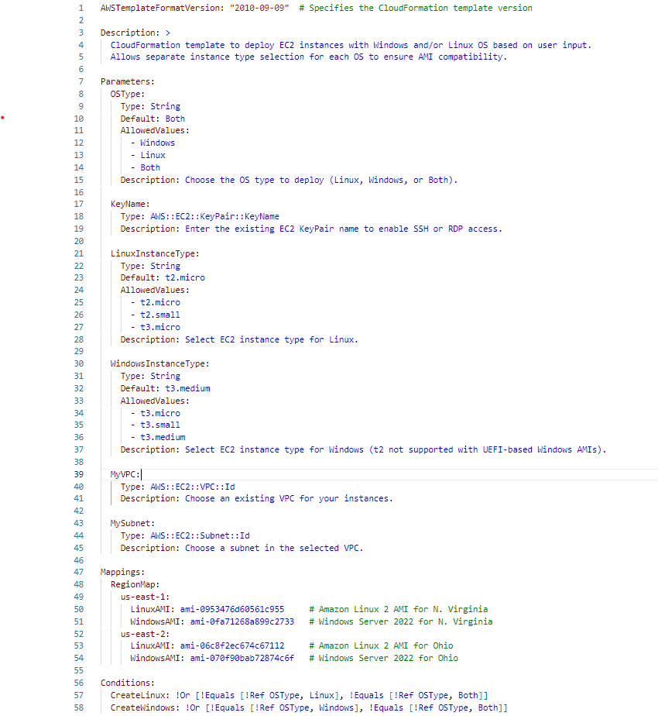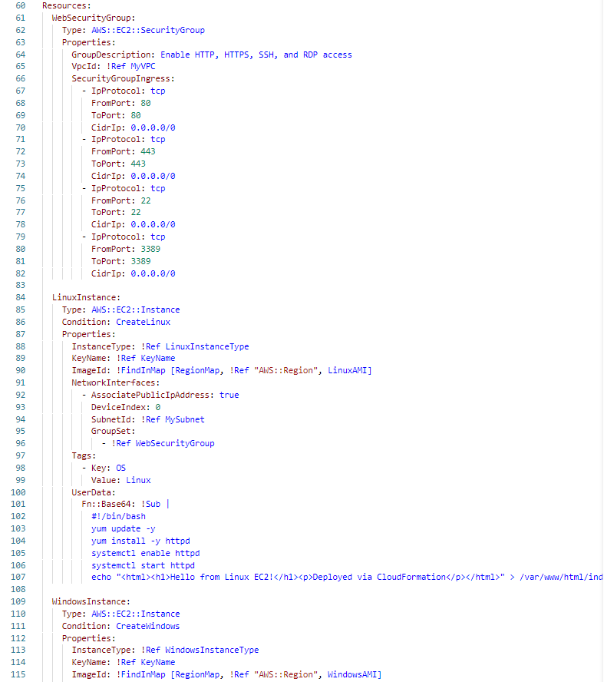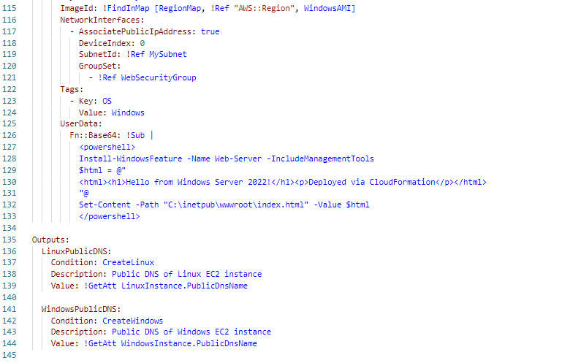

**5. Choose AMI (OS Logic Step)**

* User selects one: Windows / Linux / Both
* Conditional resources are created in the CloudFormation Template

**6. Create Key Pair**

* Go to EC2 > Key Pairs > Create Key Pair
* Select .pem format and save the file securely

**7. Search for CloudFormation**

* Search "CloudFormation" in the AWS Console

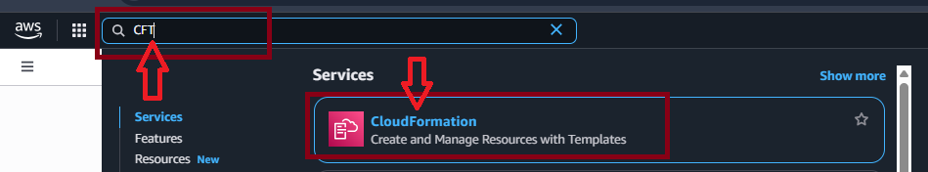

**8. Open CloudFormation Console**

* Open the CloudFormation service

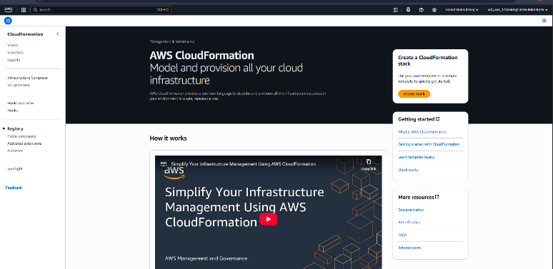

**9. Create Stack (Where to Click)**

* Begin the stack creation process

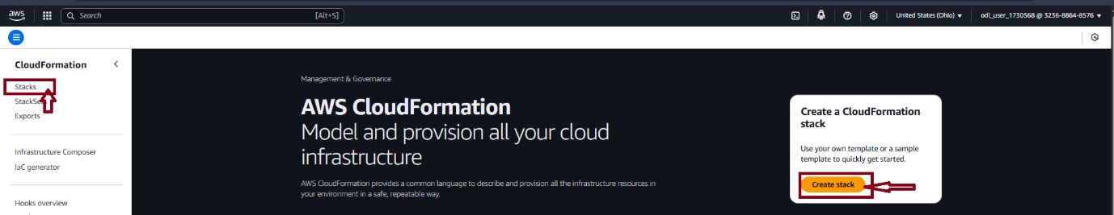

**10. Create Stack from Template**

* Upload your template file

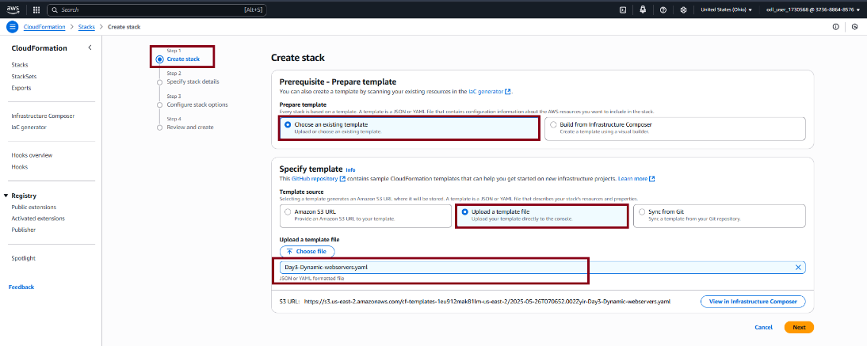

**11. Specify Stack Details**

* Provide stack name, parameters, and select the key pair

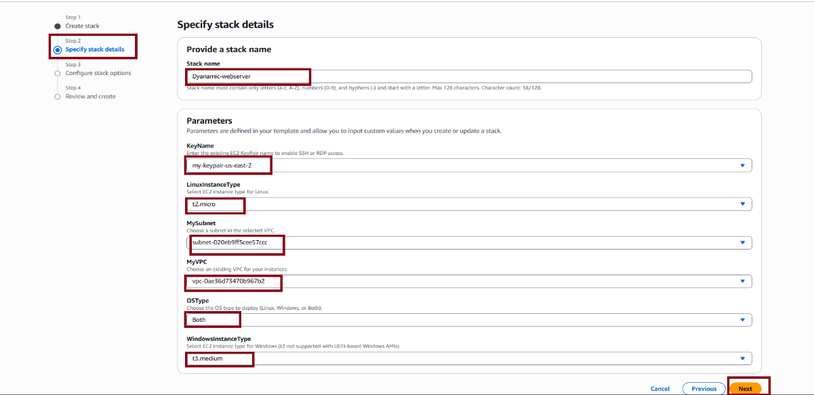

**12. Configure Stack Options**

* Leave default or configure additional options

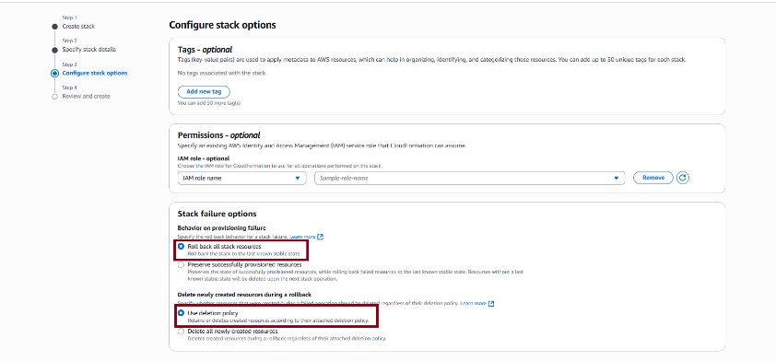

**13. Review and Create Stack**

* Review configurations and click Create Stack

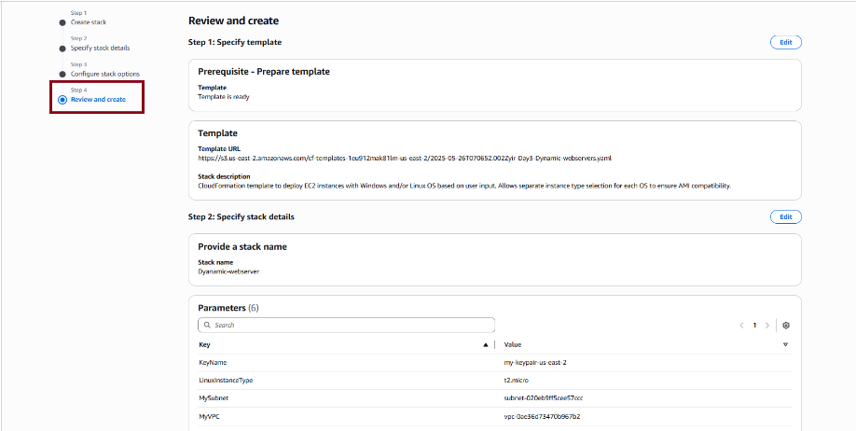

**14. Stack Created Successfully**

* Confirmation of successful stack creation

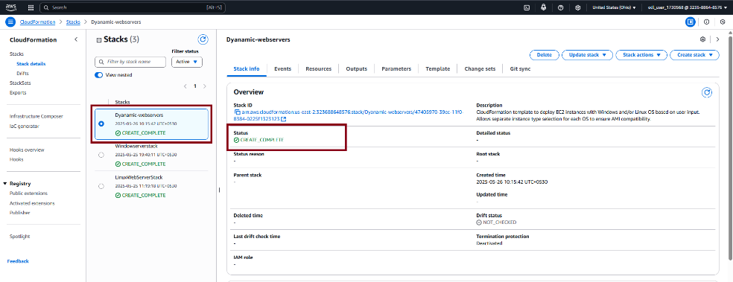

**15. EC2 Search Page**

* Go to EC2 and search for running instances

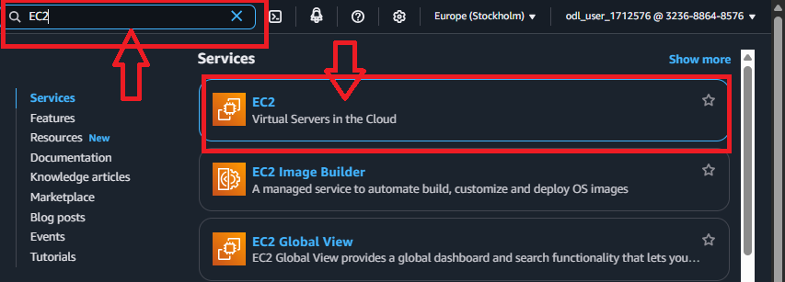

**16. EC2 Dashboard**

* View list of created EC2 instances

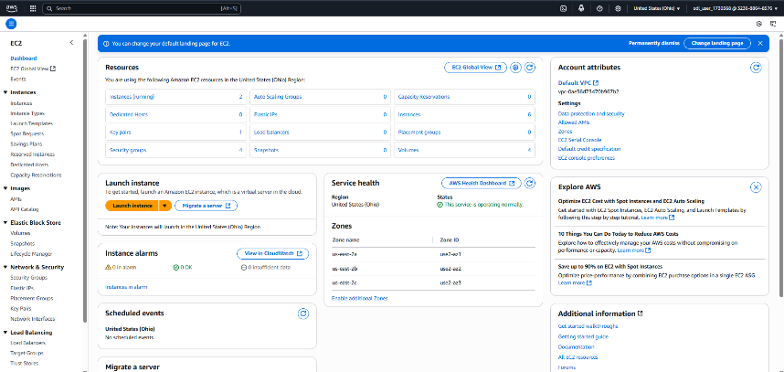

**17. Linux Instance Running**

* Linux EC2 instance is now active

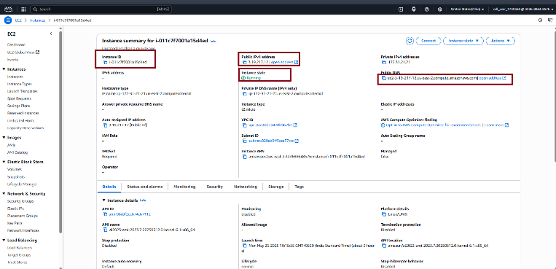

**18. Linux Web Server Page**

* Apache server serves the HTML template

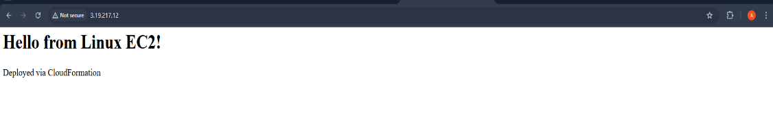

**19. Windows Instance Running**

* Windows EC2 instance is now active

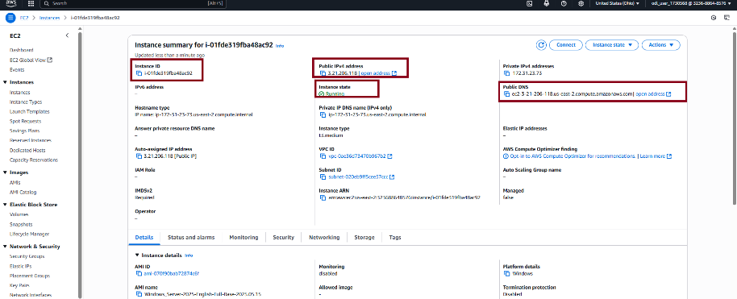

**20. Windows Web Server Page**

* IIS server serves the HTML template

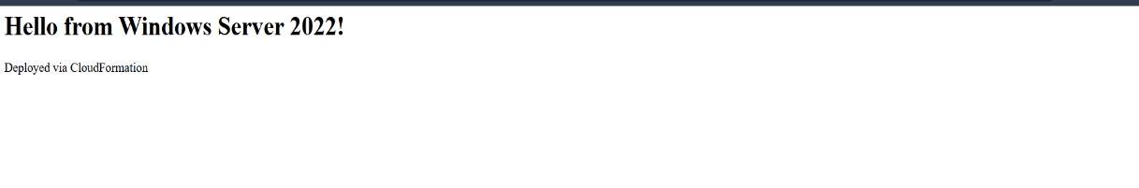

**Deployment in Region: us-east-2**

* Follow the same steps after switching the AWS region to us-east-2

**Challenges Faced**

* Initially, did not specify t3 instance type for Windows — template failed
* Encountered error “This site can’t be reached” using public IP  
  ➤ Fixed by manually typing http://<public-ip> instead of just <public-ip>
* Debugging CloudFormation stack events helped understand which condition/resource failed

**References**

* AWS CloudFormation Documentation: <https://docs.aws.amazon.com/cloudformation/>
* HTML Templates: [https://html5up.net](https://html5up.net/)
* EC2 User Data Scripts: <https://docs.aws.amazon.com/AWSEC2/latest/UserGuide/user-data.html>
* Personal testing and experimentation

**Conclusion**

Live Linux and Windows web servers successfully deployed on AWS using a single dynamic CloudFormation template. Fully automated, scalable, and region-independent deployment achieved.

**GitHub Repository**  
The complete project files and code can be accessed here:  
🔗 <https://github.com/APARNA2109/aws-cft-webservers-project>